Q-Discuss various applications of liquid crystals. Or Explain the display mechanism in liquid crystals. Or Explain the electro-optic effect of liquid crystals. How is it utilized in display systems

1. Display systems
This is used in information display systems, where liquid crystals control the brightness or darkness of parts of a display device. Numbers can be created in numeric displays which have seven segments (also called pixels). Alphabets can be displayed on a fourteen segment arrangement.
A numeric display consists of seven segments for each digit. Each segment is a liquid crystal. Light emitted by each crystal can be independently controlled so that any digit can be displayed. When an electric field is applied to a segment, the liquid crystal is deformed and when polarized light is incident, it gets brightened. By using dichroic dyes, the contrast between bright and dark areas can be enhanced and required colours can be obtained.
One of the most important effects of electroptic effect (of nematic and chiral liquid crystals) is in liquid display systems (LCD). Electro-optic effect of liquid crystal controls brightness and darkness of emergent light.
LCD requires a very small current. Most of the display in LCD watches and calculators composes of 7 segments. Each seven segments section can display one number. The 14- segments LCD are used of alphabets. Light from the area of each segment are controlled independently and creation of any digits or alphabets is possible. 5x7 matrix segments are used for numbers, letters and figures.
A 7-segment display (Figure 14) consists of seven segments for each digit (each segment represents a liquid crystal). Light from the area of each of the seven segments or pixels is controlled independently and creation of any of the ten digits becomes possible. When an electric field is applied to a segment, the liquid crystal in that segment undergoes deformation (is activated) and when polarized light is incident, the segment gets brightened. A typical liquid crystal display cell (reflection mode) and the electrical circuit with four rows and two columns for a digit to appear is shown in below Figures.
Transparent electrodes Glass plates
Liquid Reflector
crystal
Seal

Figure 13 : Representation of a liquid crystal display (reflection mode pixel) where the liquid crystal is embedded between two glass plates
In the Figure 14, when voltage applied to
i) Row 1 column I activate the liquid crystal in an area a which gets brightened.
ii) Row 2 column I activates the liquid crystal in an area d which gets brightened.
iii) Row 3 column I activates the liquid crystal in an area e which gets brightened.
iv) Row 1 column II activates the liquid crystal in an area b which gets brightened.
v) Row 2 column II activates the liquid crystal in an area c which gets brightened.
vi) Row 3 column II activates the liquid crystal in an area f which gets brightened.
vii) Row 4 column II activates the liquid crystal in an area g which gets brightened.

(b)
(a)
Row 4
Row 3
Row 2
Row 1
Column I
Column II
a
c
b
d
e
f
g

Figure 14: Seven segment LCD for a digit; each row is connected to two segments and each column is connected to three or four segments; a, to g are the LCD cells. (b) display of number 139
For example, to get a number 139 on the display (Fig.b) an electric field is applied between row 2 and column II (operation v) and between row 3 column II (operation vi) to give ‘1’
In the second digit operations (i), (v), (vi) and (vii) give ‘3’
In the third digit operations (i), (ii), (iv), (v), (vi) and (vii) give ‘9’. Thus the digits 139 appears on the display.
To enhance the difference in the brightness between dark (turned OFF, voltage removed) and bright areas (turned ON, voltage applied), dyes are used. Dyes used in liquid crystal displays are called dichroic dyes and give desired colours to the displays with a good contrast.
Various electric equipments use LCD’s :
- Calculators, watches, mobile, telephones, laptops.
- Indicators used in traffic signals, advertisement boards, petrol pump indicators etc.
- In analytical instruments like pH-meter, conductometer, colorimeter, potentiometer etc.
Display Devices
Organic Light Emitting Diodes (OLED) and their Applications
OLEDs are thin-film organic semiconductor light-emitting devices. also known as organic electroluminescent (organic EL) diode, is a light-emitting diode (LED) in which the emissive electroluminescent layer is a film of organic compound that emits light in response to an electric current. This organic layer is situated between two electrodes; typically, at least one of these electrodes is transparent.
OLED consist of a thin film of organic material sandwiched between two electrodes (anode and cathode). Anode is transparent and made of indium tin oxide. Cathode is reflective and made of metal. When an external potential is applied across electrodes, positive and negative charges (holes from anode and electrons from cathode) are injected. These electrons and holes shift inside the material and recombine to form excitons, emitting photons in the process.
Based on their number of layers, OLEDs can be classified as two-layer and three-layer OLEDs. In two-layer OLEDs, electrons are injected from cathode into the lowest unoccupied molecular orbital. Simultaneously, holes are injected from anode into the highest occupied molecular orbital. The figure given below depicts bilayer light emitting display.
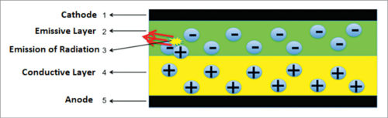
Fig. : OLED

An OLED consists of:
1. Substrate. Regarded as the base of an OLED, it is made up of a thin translucent glass or foil material.
2. Anode. It is also called as emitter. Its main function is to emit electrons when a voltage is applied across terminals.
3. Cathode. Cathode is the topmost part of OLED displays. It injects electrons when a potential difference is applied across terminals.
4. Organic layer. The layer above anode is called organic layer. It contains conductive polymer made of hydrogen or carbon molecules.
5. Conductive layer. This layer is made of organic plastic molecules and helps to move holes from anode.
6. Emissive layer. This layer is made of organic materials, it helps to transport electrons from cathode.
Properties of OLED:
- OLEDs make it easier to fabricate flexible displays.
- OLEDs fit in as these consume less power and provide high-quality display.
- The current OLED technology provides remarkable colour fidelity,
- high efficiency and operation stability
- high reliability and readability.
Applications of OLED: are mainly used
- in digital devices such as high-end television systems,
- computer monitors,
- pocket-size systems such as Android phones,
- media players,
- digital cameras,
(vi) portable gaming consoles and mini-screens.

Quantum dot-based light emitting diodes (QDLEDs / QLED’s) are a new form of light emitting technology based on nanoparticle, and their structures are similar to the OLED technology. Although, in this technology, a layer of quantum dots is placed between electron and hole-transporting layers, like sandwiched structure. A quantum dot display is a display device that uses quantum dots (QD), semiconductor nanocrystals which can produce pure monochromatic red, green, and blue light. Photo-emissive quantum dot particles are used in LCD backlights and/or display color filters. Quantum dots are excited by the blue light from the display panel to emit pure basic colors, which reduces light losses and color crosstalk in color filters, improving display brightness and color gamut.
Design of QLEDs
QDs are composed of nano particles with range of diameters from 5 - 20nm. When charge carriers (electrons and holes) are confined to such tiny particles, the larger band gap of the surrounding substance creates a barrier. When the charge carriers (electron – hole pairs) eventually recombine, a characteristic photon is emitted.
QLED consist of a thin film of quantum dot materials sandwiched between two electrodes (anode and cathode). When an external potential is applied across electrodes, positive and negative charges (holes from anode and electrons from cathode) are injected. These electrons and holes recombine to emit photon.
QLEDs or QDLED is considered as a next generation display technology after OLED-displays. The structure of a QDLED is analogous to that of an OLED. An applied electric field causes electrons and holes to move into the Quantum dot layer, where they are captured in the Quantum dot layer, emitting photons. QDLEDs are basically a genuine example of electroluminescence. They provide the hard-to-reach blue end of the spectrum, and are the key for opening any number of exciting technological developments.

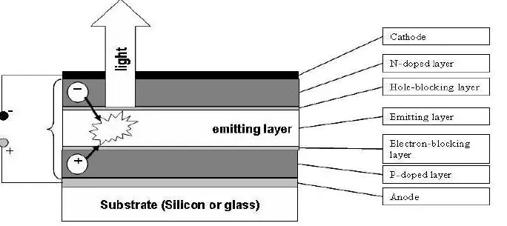
Fig.: QLED

Properties of QDLEDs
- QLEDs are a reliable, energy efficient, tunable colour solution for display and lighting
- QLEDs are characterized by pure and saturated emission colours with narrow band width.
- Quantum dots (QDs) have many unique optical properties such as high photoluminescence (PL) quantum yield (QY), high color purity,
- Size-tunable emission wavelength and solution-processed synthesis, which make them promising materials for next-generation light-emitting diodes (LEDs) in display and lighting applications
Application of QLEDs: Quantum dot light-emitting diodes (QD-LEDs) are widely recognized as great alternatives to organic light-emitting diodes (OLEDs) due to their enhanced performances. For the last ten years, OLEDs have been predominantly used in flat panel display technologies because of their ability to produce bright, smooth pictures. They find following applications
(i) Quantum dots have revolutionized the field of light-emitting diodes. Quantum dots can provide a wide variety of colors depending on their size and composition The color emitted by light-emitting diode can be tuned by either decreasing or increasing the size of quantum dots of the particular material used. These find application in some crucial fields such as display and lighting technology.
(ii) These can be effectively used in night vision, data communication, agriculture, and horticulture.
(iii) Quantum dot light-emitting diodes (QLED’s) are cost- effective electroluminescence devices ideal for large-area display and lighting applications.

